**Agrix – Rice Crop Disease Detection System**

**Team Members:** Poorany Priyadharshiny T, Lakshmi Sangari S  
**College:** Anna University  
**Team:** Agrix  
  
**Abstract:-**

This paper presents an AI-enabled rice disease detection system using MobileNetV2. The model classifies nine major rice diseases with 99.2% validation accuracy. A lightweight web dashboard is also developed to support field usability.  
 **1.Introduction:-**

Agriculture is the backbone of India’s economy, with rice being one of the most widely cultivated crops. However, rice is prone to fungal and bacterial diseases that lead to large-scale yield reduction. Early detection is crucial but challenging due to limited expert availability and delayed visual identification by farmers.

**Agrix** addresses this issue through a **Cyber-Physical System (CPS)** powered by **Deep Learning**, enabling real-time disease detection using images of rice leaves. The system provides immediate advisory, helping farmers take preventive action.

Rice diseases reduce global productivity significantly. Traditional inspection is slow and subjective.  
The proposed Agrix system integrates:

* Deep Learning–based image classification
* User-friendly web interface
* Knowledge-based advisory text files

**2.Problem Statement:-**

**Farmers face multiple challenges:**

* Lack of expert agronomists in rural areas
* No real-time disease detection
* Crop monitoring is manual, slow, and error-prone
* Delayed diagnosis leads to production loss

**Agrix solves this by providing:**

* Instant disease detection
* Smartphone-based scanning
* High-accuracy CNN predictions
* Actionable symptom & prevention advice

**3.Objectives:-**

* Build a deep learning model capable of classifying 9 rice leaf conditions
* Develop a lightweight system suitable for CPS integration
* Create a real-time dashboard interface
* Enable extension to IoT-based sensing in future stages

**System Objectives:**

The primary goals of Agrix are:

1. **Accurate disease detection:** Use AI models to identify common rice diseases based on leaf images.
2. **Context-aware assessment:** Combine environmental parameters with visual diagnosis for better infection stage estimation.
3. **Actionable insights:** Provide farmers with clear guidance, including symptoms and preventive measures.
4. **User-friendly interface:** Enable easy capture, upload, and visualization of disease detection results through a web interface.
5. **Deployment-ready architecture:** Support production deployment with lightweight models and portable formats like TorchScript.

**4.System Architecture:-**

The Agrix architecture consists of:

1. Input Layer (Image Source) – Camera / Upload
2. Preprocessing Unit – Resize (224×224), normalization
3. AI Model (MobileNetV2 CNN) – Inference engine
4. Disease Knowledge Base – Text-based advisory
5. CPS Feedback Layer – Farmer action, future IoT data

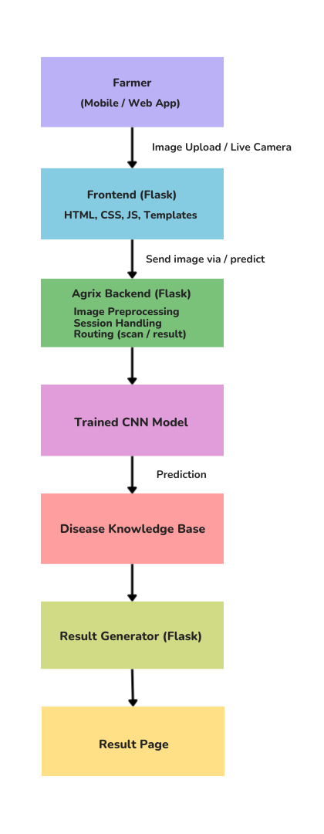

**5.Dataset:-**

A high-quality dataset is crucial for effective AI model training. Agrix employs a **structured pipeline** for preparing rice disease datasets. Agrix was trained using a curated dataset containing **9 classes**:

* Bacterial Blight
* Blast
* Brown Spot
* Sheath Blight
* Leaf Scald
* Narrow Brown Spot
* Tungro
* Leaf Blast
* Healthy

**5.1 Raw Data Collection:**

* Images are collected from multiple sources and stored in a dataset/raw folder.
* The raw dataset includes various rice leaf images representing both healthy and diseased conditions.

**5.2 Label Standardization:**

Raw images often come with inconsistent or redundant labels. Agrix employs a **canonical mapping strategy**:

* Labels like leaf_blast, rice_blast, and blast are mapped to a single class, blast.
* Similarly, bacterial leaf blight and bacterial_blight are mapped to bacterial_blight.
* Healthy or normal leaves are mapped to healthy.

This ensures that the AI model sees **consistent labels**, reducing confusion and improving prediction accuracy.

**5.3 Image Preprocessing:**

* **Resize:** All images are resized to 224×224 pixels to match the input dimensions of the CNN models.
* **Format Conversion:** Images are converted to RGB format for consistency.
* **Data Splitting:** The dataset is split into **training (80%)** and **validation (20%)** subsets.
* **Output Structure:**
* dataset/merged/train/<class_name>/
* dataset/merged/val/<class_name>/

This standardized, balanced dataset forms the foundation for **robust model training**.

**5.4 Pre-processing Steps:**

* Image resizing to 224×224
* Normalization (0–1 range)
* Augmentation: rotation, zoom, shear, flip
* Splitting into Train (80%) / Validation (20%)

**6. AI-based Disease Classification:-**

Agrix leverages Convolutional Neural Networks ( CNNs) for image-based disease detection. Two main implementations exist: TensorFlow (MobileNetV2) and PyTorch (EfficientNet-B0).

**6.1 TensorFlow Implementation:**

* **Model:** MobileNetV2 (pretrained on ImageNet).
* **Input Size:** 224×224 RGB images.
* **Data Augmentation:** To make the model robust to variations in lighting, orientation, and scale, training images are augmented using:
  + Random rotation
  + Width and height shifts
  + Zoom
  + Horizontal flips
* **Training Strategy:**
  1. Freeze the base MobileNetV2 layers and train only the top classifier layers.
  2. Fine-tune the last 50 layers of MobileNetV2 for better accuracy.
* **Loss Function & Optimizer:** Categorical Crossentropy and Adam optimizer.
* **Outputs:** Trained model (agrix_model.keras) and label mapping (labels.txt).

**6.2 PyTorch Implementation:**

* Model: EfficientNet-B0 (pretrained on ImageNet).
* Data Augmentation:
  + RandomResizedCrop
  + Horizontal flips
  + Color jitter
* Training Parameters:
  + Batch size: 32
  + Epochs: 6
  + Learning rate: 1e-4
* Loss & Optimizer: CrossEntropyLoss with Adam optimizer.
* Validation: Accuracy is monitored after each epoch, and the best model weights are saved (best_weights.pth).
* Deployment Preparation: Model exported to TorchScript (rice_model_ts.pt) for fast, portable inference.

**6.3 Fallback Prediction:**

To ensure functionality even without a trained model:

* A heuristic predicts “healthy” or assigns probabilities to diseases based on green vs red pixel intensity in the leaf image.
* Provides minimal but functional predictions for demo purposes.

**7. Challenges in Dataset:-**

Agrix uses augmentation to reduce overfitting and improve robustness.

* Class imbalance
* Variations in lighting and background
* Differences in disease stages

**8. Model Architecture:-**

Agrix uses MobileNetV2 due to its lightweight design and high accuracy for mobile-CPS systems.

**Layers used**

* MobileNetV2 (pretrained on ImageNet, frozen)
* GlobalAveragePooling2D
* Dense Layer (128 units, ReLU)
* Dropout (0.3)
* Output Softmax Layer (9 classes)

**Training Setup**

* Optimizer: Adam
* Loss: Categorical Crossentropy
* Epochs: 10 + 3 fine-tuning
* Batch Size: 16

**9. Performance Metrics:-**

The model generalizes well due to controlled augmentation and fine-tuning of top layers.

**Model Accuracy**

* Training Accuracy: 98.64%
* Validation Accuracy: 99.22%
* Inference Time: 0.3 seconds per image

**10. CPS (Cyber-Physical System) Integration:-**

Agrix is designed for CPS scalability:

**CPS Components**

* **Physical Layer:**  
  Smartphone camera, future IoT leaf sensors, drones
* **Cyber Layer:**  
  CNN model, disease advisory engine, cloud
* **Human Layer:**  
  Farmer input, dashboard interaction

**Future Enhancement**

* IoT humidity/temperature sensor fusion
* Drone-based aerial rice field monitoring
* Automated pesticide recommendations

**11. UI Workflow:-**

**Dashboard Pages**

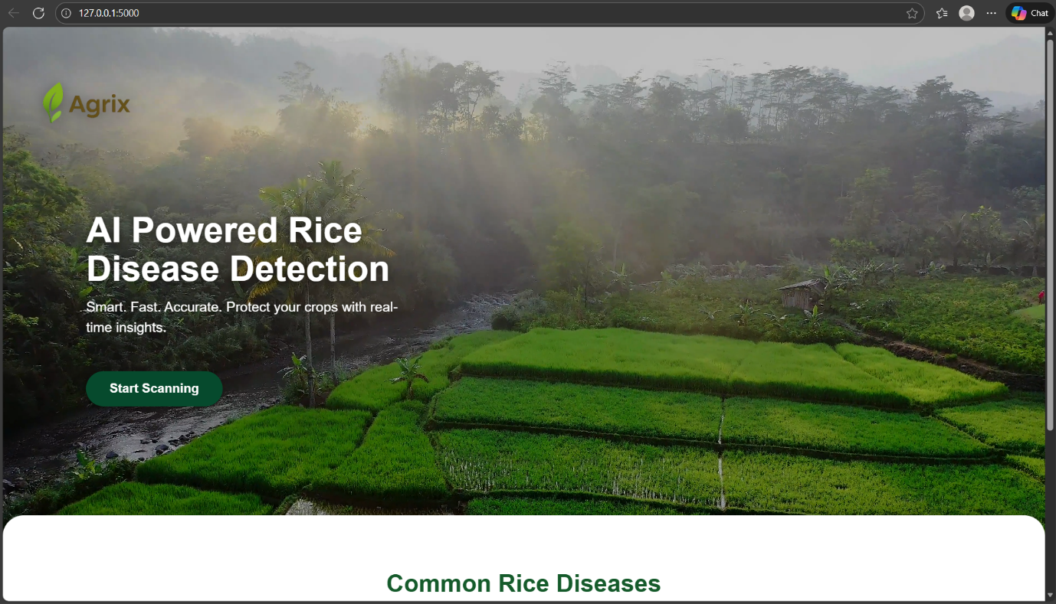**Page 1:** Cover Page – Intro + Get Started

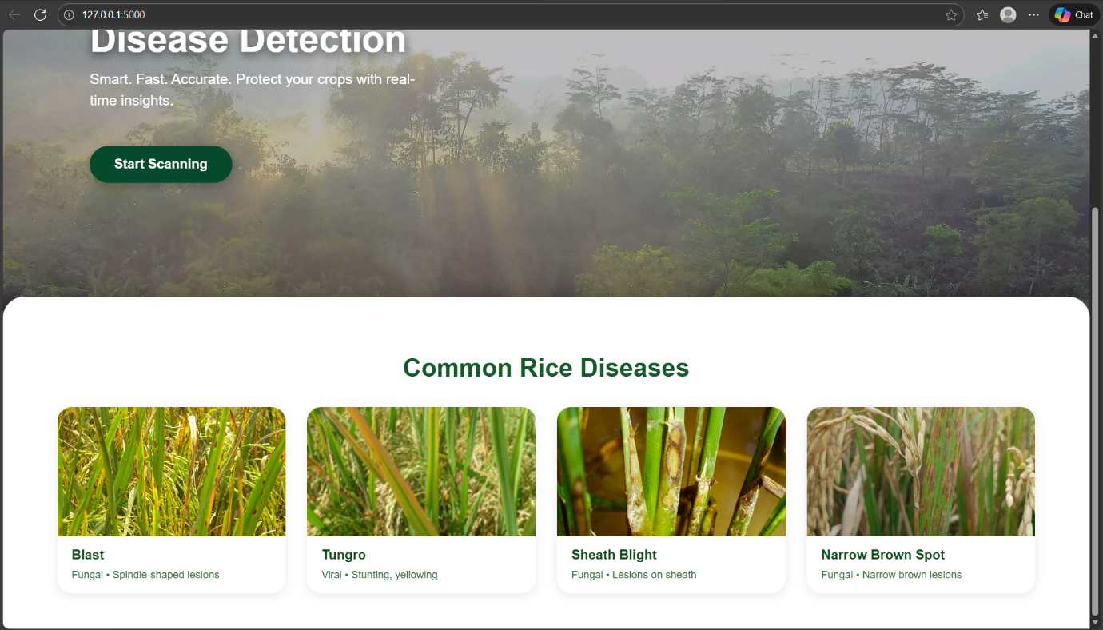

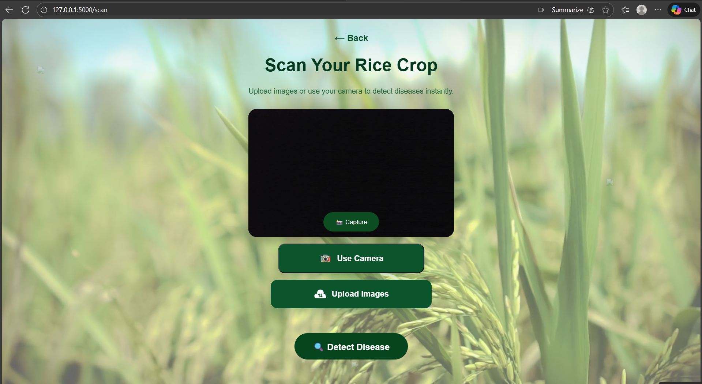**Page 2:** Scan Page – Upload / Camera capture

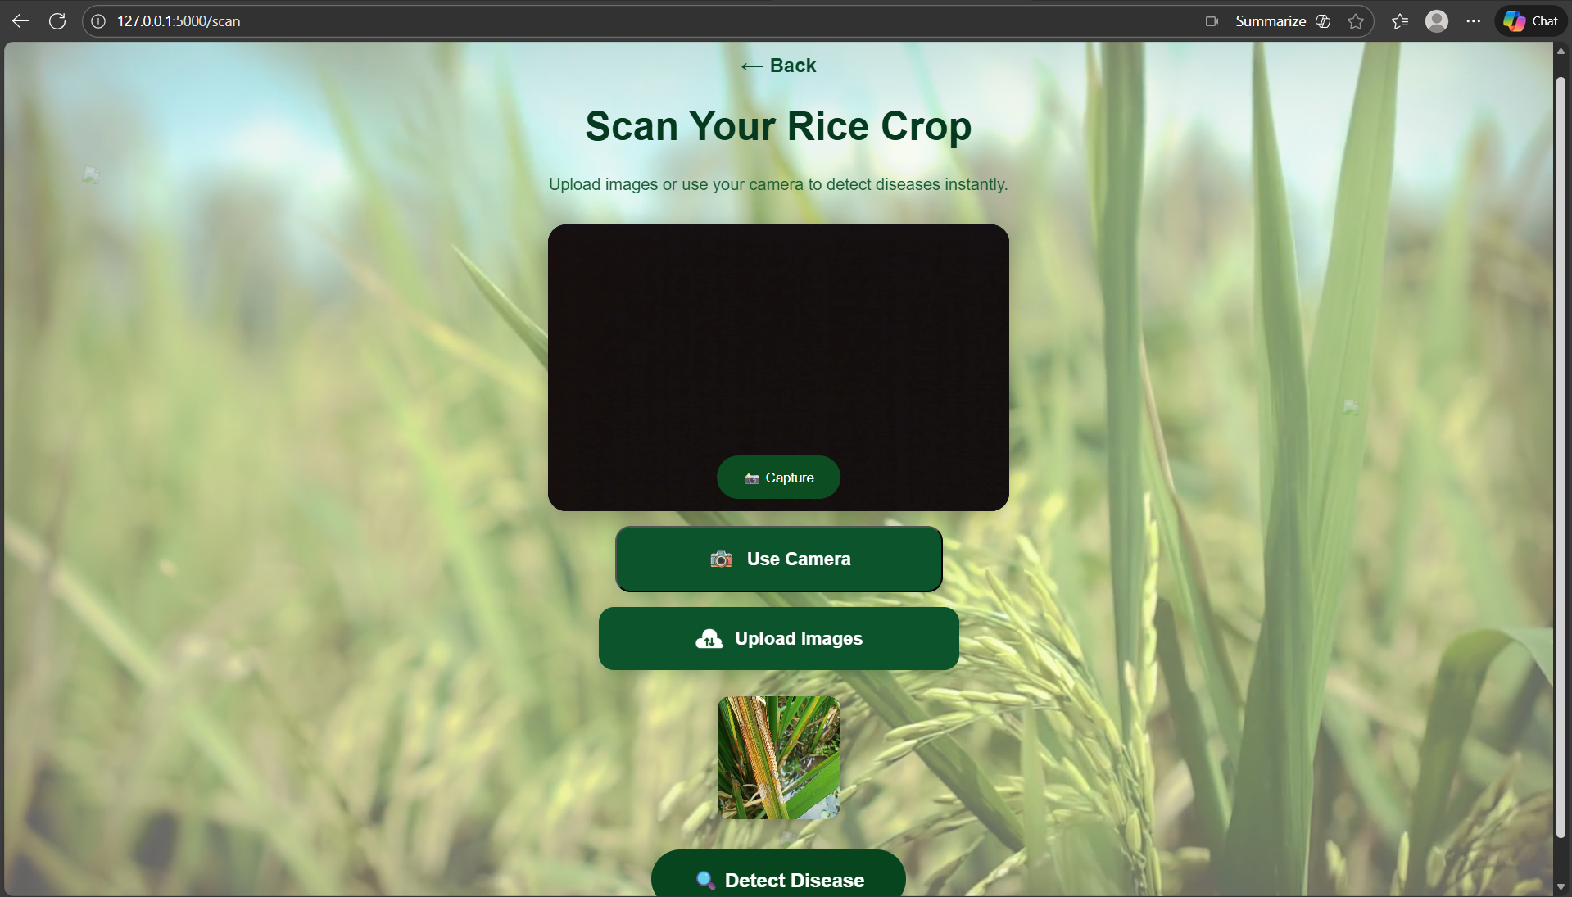

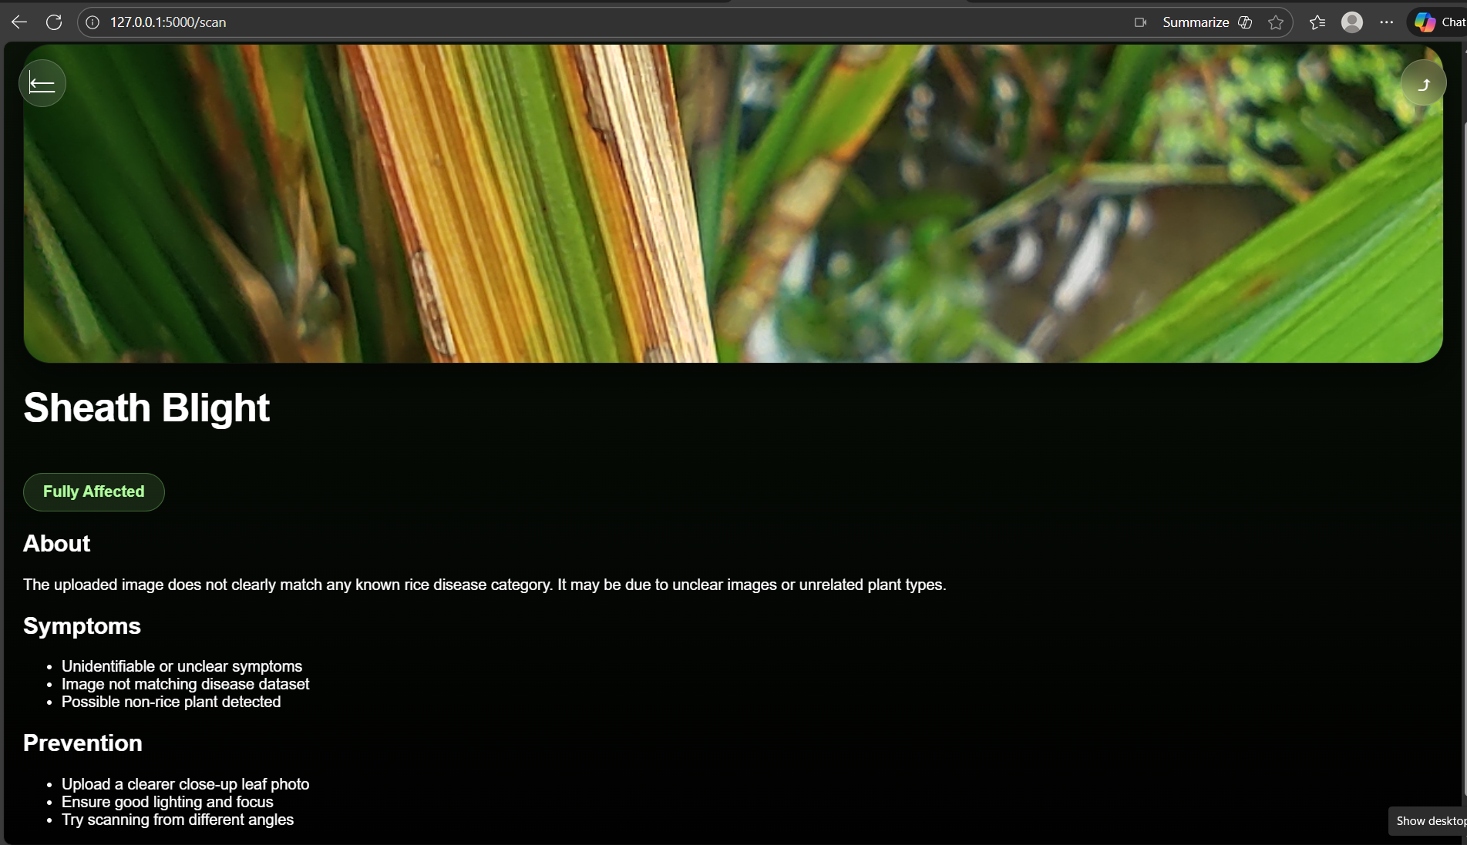**Page 3:** Result Page – Disease, symptoms, prevention

**12. Conclusion:-**

Agrix provides a highly accurate AI-driven rice disease detection system built for practical field deployment. It aligns with the CPS framework, enabling real-time decision-making for farmers. The system is scalable, efficient, and ready for multi-crop extension and IoT integration.